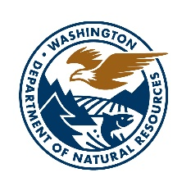

WASHINGTON DEPARTMENT OF NATURAL RESOURCES

NATURAL AREAS PROGRAM

RESEARCH PERMIT APPLICATION

Contact Information: Please include your name, affiliation (if any), mailing address, email address, and phone number.

Please address each of the items below as they pertain to your project. If any item(s) are not applicable, indicate “N/A”. Natural Areas Program staff will review your application and respond with any questions or needed clarifications. If approved, you will then receive a permit for review and signature.

- Project Description
  - introduction and purpose
  - natural area(s) for which you are requesting a permit. Click to see a map and additional information about DNR-managed natural areas.
  - rationale for selecting natural area(s) rather than alternative site(s)

- Research Activity
  - type of sampling, if any
  - type and scope of manipulative work, if any
  - provide details pertaining to any destructive sampling methods (e.g. locations, how often, how long,) and rationale for use of destructive methods
  - provide details pertaining to any ground-disturbing activities and rationale for using these methods
  - other activity associated with research (e.g. entry points, access routes, mode of access, flagging or other field identification procedures)
  - size and location of research sites
  - number of researchers, size of groups, frequency of site visits
  - expected duration of project
  - frequency of sampling/recording/visitation

- Instrumentation
  - describe field sampling instruments
  - show/describe location of instruments or other structures
  - method of field marking instruments (if any)
  - length of time instruments will be in the field

- Final Products
  - type of products(s) anticipated (e.g. thesis, journal, monograph, unpublished manuscript)
  - timeline for each product

